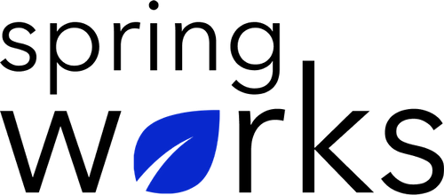
Employee Pulse Survey Template: Post-Training

Use this template if you would like to evaluate the effectiveness of your learning and development initiatives or compare across several programs.

This pulse survey will elicit feedback that can also help improve and optimize your learning programs over time.

Q: Overall, on a scale from 1 to 5, how would you rate this training session?

1 | 2 | 3 | 4 | 5

Q: Overall, on a scale from 1 to 5, how would you rate the effectiveness of the instructor(s)?

1 | 2 | 3 | 4 | 5

Q: The objectives of the training were clearly defined.

- Strongly agree
- Agree
- Neutral
- Disagree
- Strongly disagree

Q: What did you find most effective about this training session?

Q: The materials (e.g., PPTs, handouts, videos, etc.) used in the training were appropriate for this subject.

- Strongly agree
- Agree
- Neutral
- Disagree
- Strongly disagree

Q: How can we make this training session more beneficial for future attendees?

Q: I can start implementing the training and lessons learned immediately in my work.

- Strongly agree
- Agree
- Neutral
- Disagree
- Strongly disagree

Q: There was an adequate opportunity for questions and interactions.

- Strongly agree
- Agree
- Neutral
- Disagree
- Strongly disagree

Q: The time allotted for the training was sufficient.

- Strongly agree
- Agree
- Neutral
- Disagree
- Strongly disagree

Q: Is there anything else you would like to add?

